**Wireless Door Latch**

**Abstract**

Introduction using physical keys to lock or unlock the door is the most natural way and everyone is acquainted with it. The physical key is a well-tested and well-known technology, but it also has its flaws. There can only be one unique key for a lock. For different locks you have different keys. Furthermore, carrying a large number of keys is a burden and increases the chance of keys getting stolen, misplaced or lost. Our goal is to design a solution for secure access control that can replace physical keys for accessing door. We propose a solution using wireless door latch providing wireless unlocking via keypad. The design will allow easy implementation and distribution of keys and the device will work autonomously. This will enhance the security and will eliminate the need of carrying physical keys.

In 21st century security and privacy is the first and foremost priority of the people let it be house, office and even our data. So we wanted to upgrade the regular door locking system. By this project we secure (or) lock the premises by digital pin code. Once we enter the pin then the door gets unlocked and sound is produced intimating the doors opening or closing and also added many more features. This helps the authority to enclose the key to only one representative rather telling it to all the user.

**CONTENTS**

|  |  |  |
| --- | --- | --- |
| ABSTRACT | - | 1 |
| CONTENTS | - | 2 |
| LIST OFFIGURES | - | 3 |
| INTRODUCTION | - | 4 |
| COMPONENTS REQUIRED | - | 5 |
| DESCRIPTION | - | 6 |
| BLOCK DIAGRAM | - | 25 |
| PROPOSED APPROACH | - | 26 |
| FLOW CHART | - | 27 |
| PROPOSED SOLUTION | - | 28 |
| CIRCUIT DIAGRAM | - | 29 |
| SCHEMATIC DIAGRAM | - | 30 |
| CODE | - | 31 |
| CONCLUSION  APPLICATIONS | -  - | 34  34 |
| REFERENCE | - | 35 |

**LIST OF FIGURES**

|  |  |  |
| --- | --- | --- |
| Fig 1 | Arduino UNO R3 | Page 6 |
| Fig 2 | Arduino UNO R3 Pinout diagram | Page 8 |
| Fig 3 | 4X4 Key Pad | Page 12 |
| Fig 4 | PIR Sensor | Page 15 |
| Fig 5 | Servo Motor | Page 18 |
| Fig 6 | Buzzer | Page 21 |
| Fig 7 | LED | Page 23 |
| Fig 8 | Block Diagram | Page 25 |
| Fig 9 | Circuit Diagram | Page 29 |
| Fig 10 | Schematic Diagram | Page 30 |

**Introduction**

Various control systems have been designed over the years to prevent access to unauthorized user. The main aim for providing locks for our home, school, office, and building is for security of our lives and property. It is therefore important to have convenient way of achieving this goal.

Automatic door systems have become a standard feature on many different types of buildings and homes. And they are becoming popular every day to develop effective electronic devices which provide security. Home security has been a major issue because of the increase in crime rate and everybody wants to take proper action to prevent unauthorized user. There was a necessity to automate home so that user can take advantage of the computer control system. The devices like a telephone land line or the Global System of Mobile communication (GSM) can provide features which can be used domestically to handle appliances like; door, television, robotic arm, refrigerator, air condition, electric bulb, etc.

**WIRELESS PASSWORD BASED DOOR LOCK SYSTEM**

Wireless Password Based Door Lock System increases the security level to prevent an unauthorized unlocking done by attacker. This Wireless password based lock system will give user more secure way of locking-unlocking system. If the user is detected going out the door will be locked automatically. When the user comes back she/he needs to enter the password to unlock the door.

**WHY TO OPT WIRELESS SYSTEM**

Nowadays wireless communication is replacing the wired system which are very messy and also difficult to setup. Wired system requires proper planning and construction works for efficient and clean design. It is the reason wireless communications are replacing the wired ones. Wireless System provides more flexibility and extensibility. That is, its installation is free from construction works since it requires no cabling works. Although many of wireless network solutions such as Bluetooth, Ultra Wide Band (UWB), Wireless Ethernet, and many more, are in the area of home networking, ZigBee, a newly developing protocol for wireless sensor networks based on the 802.15.4 specification, has become the most attraction technique in the research and commercial domains because of open standard, low-cost, and low power characteristics. Therefore, comparing to the other wireless technologies, ZigBee protocol is suitable for system environments, which demands less power consumption and lower data-rates requirements.

**COMPONENTS REQUIRED**

* ARDUINO UNO
* 4X4 KEYPAD
* PIR SENSOR
* SERVO MOTOR
* BUZZER
* LED
* RESISTORS

**DESCRIPTION**

ARDUINO UNO:

Arduino UNO is a microcontroller board based on 8-bit ATmega328P microcontroller. Along with ATmega328P, it consists other components such as crystal oscillator, serial communication, voltage regulator, etc. to support the microcontroller. Arduino Uno has 14 digital input/output pins (out of which 6 can be used as PWM outputs), 6 analog input pins, a USB connection, A Power barrel jack, an ICSP header and a reset button.

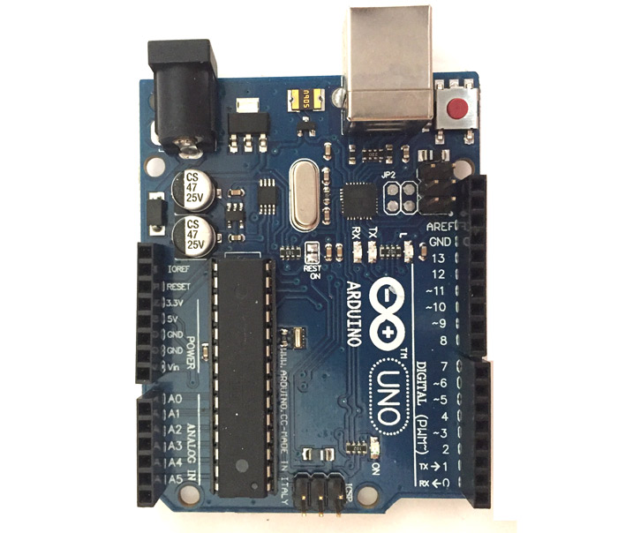

### **How to use Arduino Board**

The 14 digital input/output pins can be used as input or output pins by using pinMode(), digitalRead() and digitalWrite() functions in arduino programming. Each pin operate at 5V and can provide or receive a maximum of 40mA current, and has an internal pull-up resistor of 20-50 KOhms which are disconnected by default.Out of these 14 pins, some pins have specific functions as listed below:

* Serial Pins 0 (Rx) and 1 (Tx): Rx and Tx pins are used to receive and transmit TTL serial data. They are connected with the corresponding ATmega328P USB to TTL serial chip.
* External Interrupt Pins 2 and 3: These pins can be configured to trigger an interrupt on a low value, a rising or falling edge, or a change in value.
* PWM Pins 3, 5, 6, 9 and 11: These pins provide an 8-bit PWM output by using analogWrite() function.
* SPI Pins 10 (SS), 11 (MOSI), 12 (MISO) and 13 (SCK): These pins are used for SPI communication.
* In-built LED Pin 13: This pin is connected with an built-in LED, when pin 13 is HIGH – LED is on and when pin 13 is LOW, it’s off.

Along with 14 Digital pins, there are 6 analog input pins, each of which provide 10 bits of resolution, i.e. 1024 different values. They measure from 0 to 5 volts but this limit can be increased by using AREF pin with analog Reference() function.

* Analog pin 4 (SDA) and pin 5 (SCA) also used for TWI communication using Wire library.

Arduino Uno has a couple of other pins as explained below:

* AREF: Used to provide reference voltage for analog inputs with analogReference() function.
* Reset Pin: Making this pin LOW, resets the microcontroller.

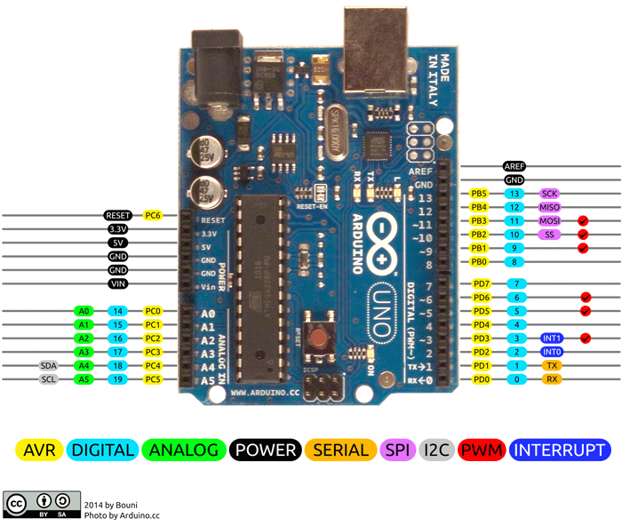

**Technical Specifications of the Arduino UNO:**

* Microcontroller: ATmega328
* Operating Voltage: 5V
* Input Voltage (recommended): 7-12V
* Input Voltage (limits): 6-20V
* Digital I/O Pins: 14 (of which 6 provide PWM output)
* Analog Input Pins: 6
* DC Current per I/O Pin: 40 mA
* DC Current for 3.3V Pin: 50 mA
* Flash Memory: 32 KB of which 0.5 KB used by bootloader
* SRAM: 2 KB (ATmega328)
* EEPROM: 1 KB (ATmega328)
* Clock Speed: 16 MHz

### **Communication**

Arduino can be used to communicate with a computer, another Arduino board or other microcontrollers. The ATmega328P microcontroller provides UART TTL (5V) serial communication which can be done using digital pin 0 (Rx) and digital pin 1 (Tx). An ATmega16U2 on the board channels this serial communication over USB and appears as a virtual com port to software on the computer. The ATmega16U2 firmware uses the standard USB COM drivers, and no external driver is needed. However, on Windows, a .inf file is required. The Arduino software includes a serial monitor which allows simple textual data to be sent to and from the Arduino board. There are two RX and TX LEDs on the arduino board which will flash when data is being transmitted via the USB-to-serial chip and USB connection to the computer (not for serial communication on pins 0 and 1). A SoftwareSerial library allows for serial communication on any of the Uno's digital pins. The ATmega328P also supports I2C (TWI) and SPI communication. The Arduino software includes a Wire library to simplify use of the I2C bus.

**Software**

The Arduino Integrated Development Environment(IDE) is a cross-platfor application (for Windows,macOS,Linux) that is written in functions from C and C++. It is used to write and upload programs to Arduino compatible boards, but also, with the help of 3rd party cores, other vendor development boards.

The source code for the IDE is released under the GNU General Public License, version 2.The Arduino IDE supports the languages C and C++ using special rules of code structuring.The Arduino IDE supplies a software library from the Wiring project, which provides many common input and output procedures. User-written code only requires two basic functions, for starting the sketch and the main program loop, that are compiled and linked with a program stub main() into an executable cyclic executive program with the GNU toolkit, also included with the IDE distribution.The Arduino IDE employs the programavrdude to convert the executable code into a text file in hexadecimal encoding that is loaded into the Arduino board by a loader program in the board's firmware.By default, avrdude is used as the uploading tool to flash the user code onto official Arduino boards.

**4X4 KEYPAD**

**Keypad is used as an input device to read the key pressed by the user and to process it.**

4x4 keypad consists of 4 rows and 4 columns. Switches are placed between the rows and columns.

A key press establishes a connection between the corresponding row and column, between which the switch is placed.

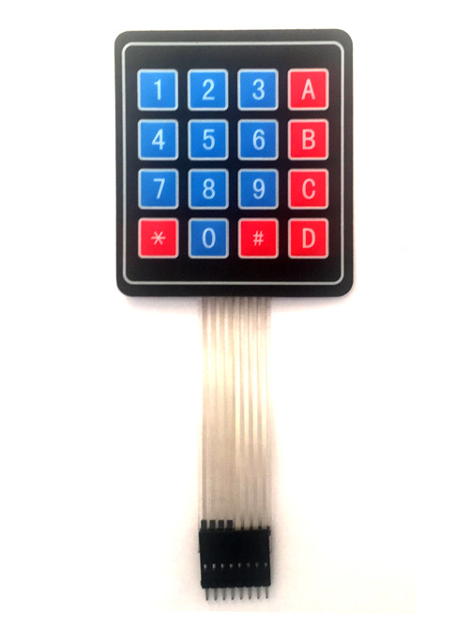

4X4 KEYPAD MODULES are available in different sizes and shapes. But they all have same pin configuration.

**PIN DESCRIPTION**

**ROWS**

* PIN1 is taken out from 1st Row
* PIN2 is taken out from 2nd Row
* PIN3 is taken out from 3rd Row
* PIN4 is taken out from 4th Row

**COLUMN**

* PIN5 is taken out from 1st Column
* PIN6 is taken out from 2nd Column
* PIN7 is taken out from 3rd Column
* 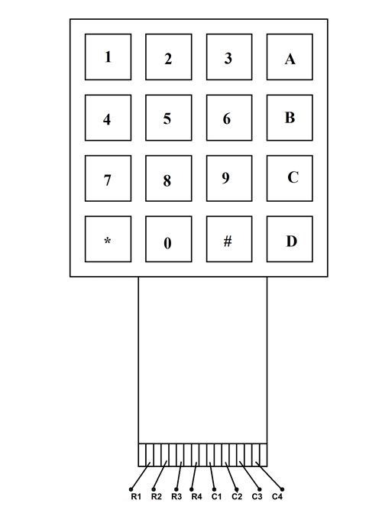PIN8 is taken out from 4th Column

### **4X4 KEYPAD MODULE Features and Specifications**

* Maximum Voltage across EACH SEGMENT or BUTTON: 24V
* Maximum Current through EACH SEGMENT or BUTTON: 30mA
* Maximum operating temperature: 0°C to + 50°C
* Ultra-thin design
* Adhesive backing
* Easy interface
* Long life.

### **Applications**

* Security systems.
* Vending machines.
* Industrial machines.
* Engineering systems.
* Measuring instruments.
* Data entry for Embedded Systems

**PIR SENSOR**

**The PIR sensor stands for Passive Infrared sensor. It is a low cost sensor which can detect the presence of Human beings or animals. This sensor has three output pins Vcc, Output and Ground as shown in the pin diagram above. Since the output pin is 3.3V TTL logic it can be used with any platforms like Arduino, Raspberry, PIC, ARM, 8051 etc...**

The module can be powered from voltage 4.5V to 20V but, typically 5V is used. Once the module is powered allow the module to calibrate itself for few minutes, 2 minutes is a well settled time. Then observe the output on the output pin. Before we analyse the output we need to know that there are two operating modes in this sensor such as Repeatable (H) and Non- Repeatable (L) and mode. The Repeatable mode is the default mode.

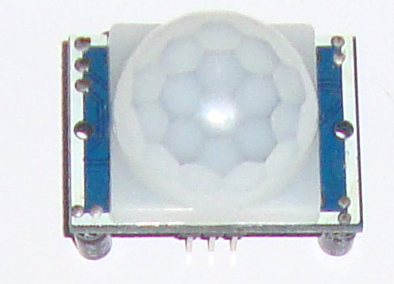

**PIN DESCRIPTION**

|  |  |  |
| --- | --- | --- |
| **Pin Number** | **Pin Name** | **Description** |
| 1 | Vcc | Input voltage is +5V for typical applications. Can range from 4.5V- 12V |
| 2 | High/Low Ouput (Dout) | Digital pulse high (3.3V) when triggered (motion detected) digital low(0V) when idle(no motion detected |
| 3 | Ground | Connected to ground of circuit |

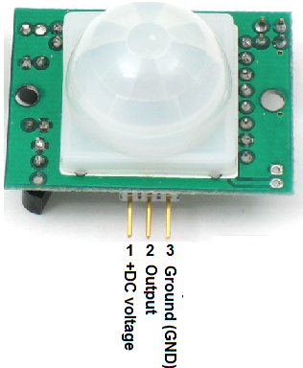

### PIR Sensor Features

* Wide range on input voltage varying from 4.V to 12V (+5V recommended)
* Output voltage is High/Low (3.3V TTL)
* Can distinguish between object movement and human movement
* Has to operating modes - Repeatable(H) and Non- Repeatable(H)
* Cover distance of about 120° and 7 meters
* Low power consumption of 65mA
* Operating temperature from -20° to +80° Celsius

### PIR Sensor Applications

* Automatic Street/Garage/Warehouse or Garden Lights
* Burglar Alarms
* Security cams as motion detectors
* Industrial Automation Control

**SERVO MOTOR**

A servo motor is a rotary actuator or motor that allows for a precise control in terms of angular position, acceleration and velocity, capabilities that a regular motor does not have. It makes use of a regular motor and pairs it with a sensor for position feedback. The controller is the most sophisticated part of the servo motor, as it is specifically designed for the purpose.

Servo motors operates from 4.8V to 6.5V, the higher the voltage higher the torque we can achieve, but most commonly they are operated at +5V. Almost all servo motors can rotate only from 0° to 180° due to their gear arrangement so make sure your project can live with the half circle if no, you can prefer for a 0° to 360° motor or modify the motor to make a full circle. The gears in the motors are easily subjected to wear and tear, so if your application requires stronger and long running motors you can go with metal gears or just stick with normal plastic gear.

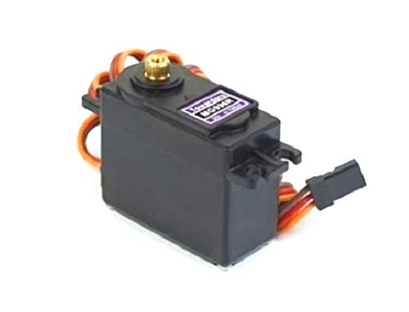

### **Wire Configuration**

|  |  |  |
| --- | --- | --- |
| Wire Number | Wire Colour | Description |
| 1 | Brown | Ground wire connected to the ground of system |
| 2 | Red | Powers the motor typically +5V is used |
| 3 | Orange | PWM signal is given in through this wire to drive the motor |

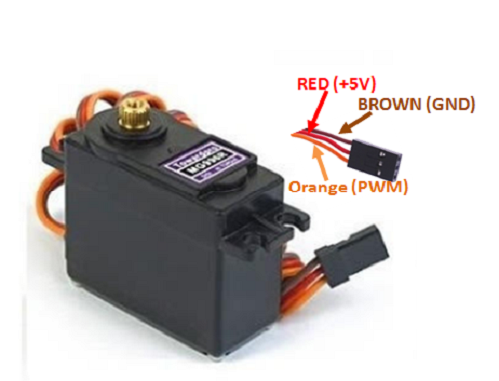

### Servo Motor **Features**

* Operating Voltage is +5V typically
* Current: 2.5A (6V)
* Stall Torque: 9.4 kg/cm (at 4.8V)
* Maximum Stall Torque: 11 kg/cm (6V)
* Operating speed is 0.17 s/60°
* Gear Type: Metal
* Rotation : 0°-180°
* Weight of motor : 55gm

### Applications

* Used as actuators in many robots like Biped Robot, Hexapod, robotic arm etc..
* Commonly used for steering system in RC toys
* Robots where position control is required without feedback
* Less weight hence used in multi DOF robots like humanoid robots

**BUZZER**

**A buzzer is a small yet efficient component to add sound features to our project/system. It is very small and compact 2-pin structure hence can be easily used on breadboard, Perf Board and even on PCBs which makes this a widely used component in most electronic applications.**

There are two types are buzzers that are commonly available. The one shown here is a simple buzzer which when powered will make a Continuous Beep sound, the other type is called a readymade buzzer which will look bulkier than this and will produce a Beep. Beep. Beep. Sound due to the internal oscillating circuit present inside it. But, the one shown here is most widely used because it can be customised with help of other circuits to fit easily in our application.

This buzzer can be used by simply powering it using a DC power supply ranging from 4V to 9V. A simple 9V battery can also be used, but it is recommended to use a regulated +5V or +6V DC supply. The buzzer is normally associated with a switching circuit to turn ON or turn OFF the buzzer at required time and require interval.

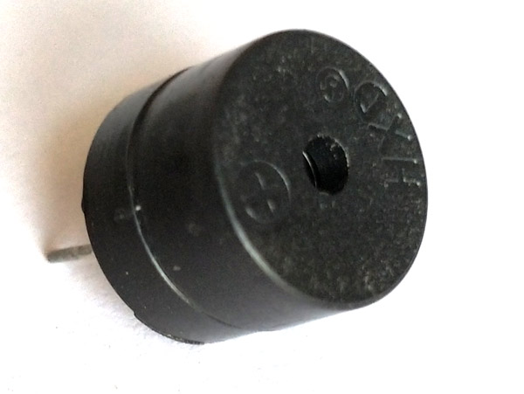

### Pin Configuration

|  |  |  |
| --- | --- | --- |
| **Pin Number** | **Pin Name** | **Description** |
| 1 | Positive | Identified by (+) symbol or longer terminal lead. Can be powered by 6V DC |
| 2 | Negative | Identified by short terminal lead. Typically connected to the ground of the circuit |

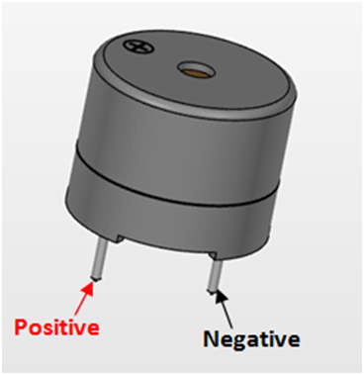

### Features and Specifications

* Rated Voltage: 6V DC
* Operating Voltage: 4-8V DC
* Rated current: <30mA
* Sound Type: Continuous Beep
* Resonant Frequency: ~2300 Hz
* Small and neat sealed package
* Breadboard and Perf board friendly

### Applications

* Alarming Circuits, where the user has to be alarmed about something
* Communication equipment
* Automobile electronics
* Portable equipment, due to its compact size

**LED**

A light-emitting diode (LED) is a semiconductor light source that emits light when current flows through it. Electrons in the semiconductor recombine with electron holes, releasing energy in the form of photons. The colour of the light (corresponding to the energy of the photons) is determined by the energy required for electrons to cross the band gap of the semiconductor. White light is obtained by using multiple semiconductors or a layer of light-emitting phosphor on the semiconductor device.

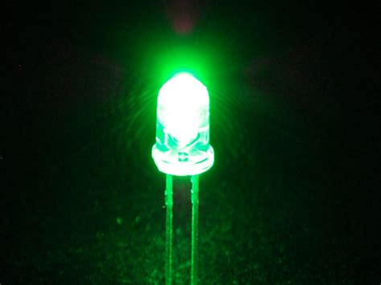

**SIMULATOR USED**

**TINKERCAD**

Tinkercad has a lot to offer as a design program, but it also serves as a replacement for Autodesk’s discontinued “123D Circuits” service, which was a free and easy to use breadboard simulator. This article will introduce you to the basics of Tinkercad Circuits which, like Fritzing, is a great design resource for makers.

Tinkercad uses a simplified constructive solid geometry method of constructing models. A design is made up of primitive shapes that are either "solid" or "hole". Combining solids and holes together, new shapes can be created, which in turn can be assigned the property of solid or hole. In addition to the standard library of primitive shapes, a user can create custom shape generators using a built-in JavaScript editor.

Shapes can be imported in three formats: STL and OBJ for 3D, and 2-dimensional SVGshapes for extruding into 3D shapes. Tinkercad exports models in STL or OBJ formats, ready for 3D printing.

Tinkercad also includes a feature to export 3D models to Minecraft Java Edition, and also offers the ability to design structures using Legobricks.

**Block Diagram**

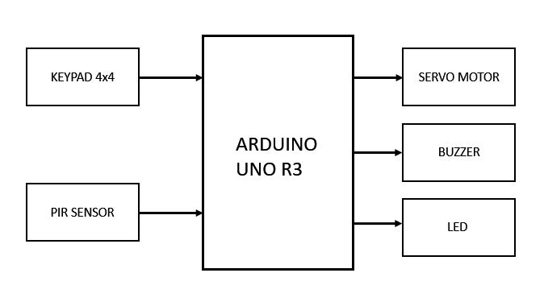

**Proposed Approach**

In order to replace traditional door lock (physical keys to lock or unlock the door) security issues we have come up with a Wireless door latch/lock system which is going to be one of the important prospects of future's fully automated systems and most significantly in the field of security.

The main theme of the project is to develop an efficient Wireless door latch/lock and as the project is based on complete simulation we have used Tinkercad platform to design the circuit and run the program. Tinkercad is a free online collection of software tools that help people all over the world think, create and make. So we divided the total system is divided into 3 sub-modules:

1. In the initial stage we read the input from the user.
2. Triggering the circuit (sensors) based on the input from the user.
3. Resetting back to the initial state once the conditions are satisfied.

So the approach is explained below:

Step 1: Get the input (4 digit PIN) from the user via 4x4 keypad

Step 2: Compare the input to check whether the input is correct or wrong

Step 3: Check whether the PIR state is high else repeat the step 1

Step 4: If it is then rotate the servo motor 90° anti-clockwise

Step 5: Once the servo is rotated then make the LED state HIGH

Step 6: Then after start the buzzer (rising tone) until the PIR sensor goes LOW

Step 7: Once the PIR sensor goes LOW then reset the circuit back the initial stage and while doing that start the buzzer (falling tone) again and keep it on till it reaches 0V.

Step 8: Repeat the step 1 again.

**Flow Chart**

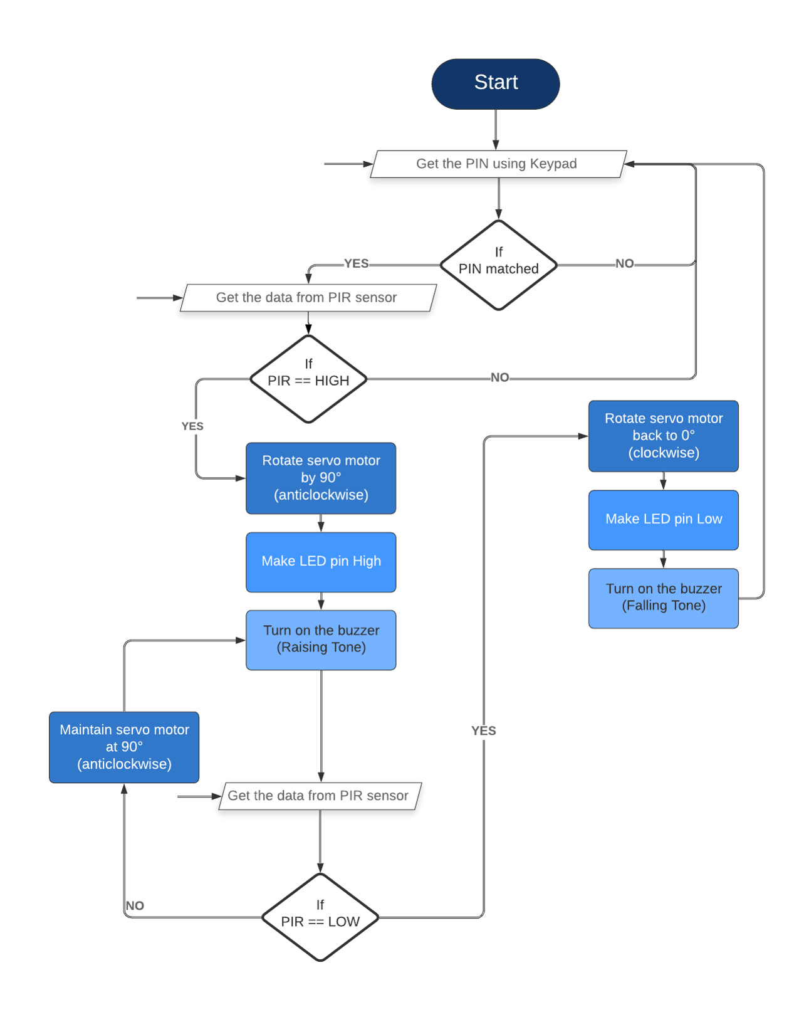

**Proposed Solution**

To tackle the above issues, we propose to replace physical keys with digital keys that:

• Can easily be distributed to users

• Can only be used by the correct user

• Can be restricted to a range

• Can be specialized for each user so each key will be unique

We propose to use a wireless system. It is as natural as carrying a physical key. Further, Smart security systems are becoming increasingly open to third-party developers, as the hardware at the same time is getting more and more powerful. This makes smart very secure for users with an ability to successfully replace the use of physical keys. The user will be required to install the hardware on the door.

Then, the following steps will be needed to carry out the process:

When the correct PIN is entered via 4x4 keypad by the user and simultaneously when PIR sensor detects the presence of Human (i.e. LOGIC HIGH) then the door gets unlocked successfully as a result the servo motor rotates at an angle of 90° (anticlockwise) and the buzzer starts pitching at two different ranges of frequencies (Rising tone) along with it the LED glow's. The buzzer produces sound and LED glow till the servo motor is maintained at that position and remains there until the PIR sensor stops detecting the infrared (IR) light radiating from human. Once the PIR sensor stops detecting (i.e. LOGIC LOW) then the servo motor retraces back to its initial position (i.e. 0°) and also the buzzer starts pitching for once and also the LED gets dim. Then the process continues from the beginning.

**Circuit Diagram**

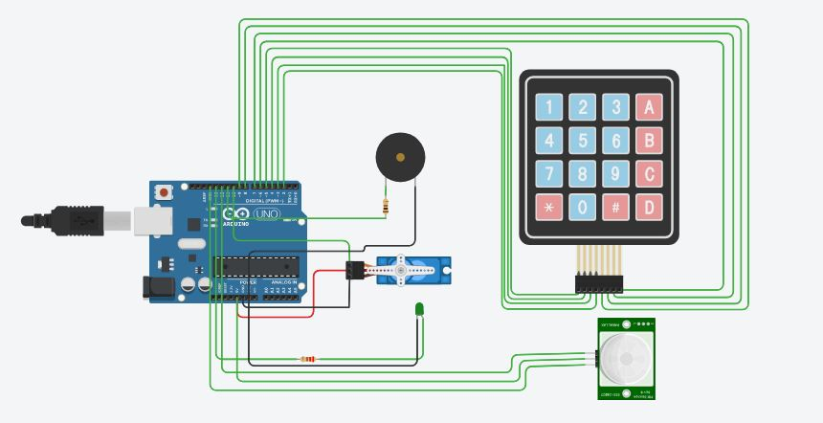

**Schematic View**

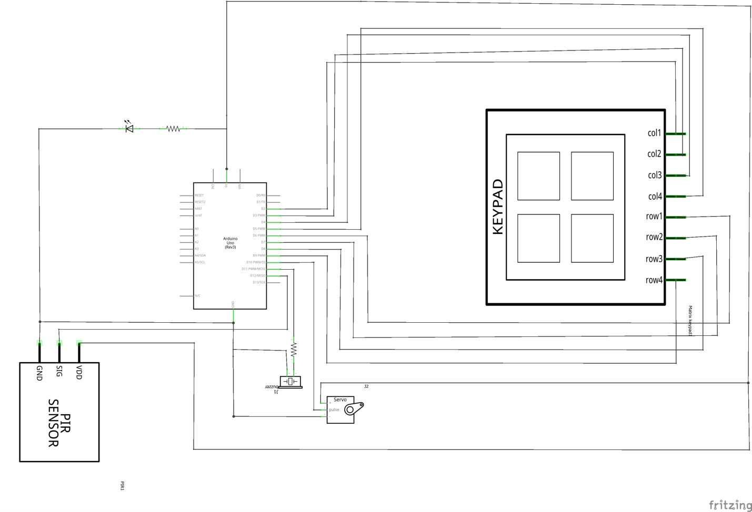

**CODE**

#include <Keypad.h>

#include<string.h>

#include <Servo.h>

Servo ser;

#define Password_Length 5

char Data[Password_Length];

char Master[Password_Length] = "1234";

byte data_count = 0, master_count = 0;

bool Pass_is_good;

char customKey;

const byte ROWS = 4;

const byte COLS = 4;

char keys[ROWS][COLS] = {

{'1','2','3','A'},

{'4','5','6','B'},

{'7','8','9','C'},

{'*','0','#','D'}

};

byte rowPins[ROWS] = {5, 4, 3, 2}; //connect to the row pinouts of the keypad (R1 R2 R3 R4 = D5 D4 D3 D2)

byte colPins[COLS] = {9, 8, 7, 6}; //connect to the column pinouts of the keypad (C1 C2 C3 C4 = D9 D8 D7 D6)

Keypad customKeypad = Keypad( makeKeymap(keys), rowPins, colPins, ROWS, COLS );

const int GledPin = 13;

const int PIR = 12;

const int speaker = 11;

int tuning;

void setup(){

pinMode(GledPin,OUTPUT);

pinMode(speaker, OUTPUT);

pinMode(PIR, INPUT);

Serial.begin(9600);

ser.attach(10);

digitalWrite(GledPin,LOW);

}

void loop(){

ser.write(0);

customKey = customKeypad.getKey();

if (customKey){

Data[data_count] = customKey;

data_count++;

Serial.print(customKey);

}

if(data_count == Password_Length-1){

if(!strcmp(Data, Master) && digitalRead(PIR)==1){

ser.write(90);

digitalWrite(GledPin,HIGH);

for(tuning = 100;tuning<=900;tuning+=100){

tone(speaker, 440 * pow(2.0, (constrain(int(map(tuning, 0, 1023, 36, 84)), 35, 227) - 57) / 22.0), 1000);

}

while(1){

tone(speaker, 440 * pow(2.0, (constrain(int(map(900, 0, 1023, 36, 84)), 35, 227) - 57) / 22.0), 1000);

if(digitalRead(PIR)==1)

continue;

break;

}

ser.write(0);

digitalWrite(GledPin,LOW);

for(int tuning =900;tuning>0;tuning-=100){

tone(speaker, 440 * pow(2.0, (constrain(int(map(tuning, 0, 1023, 36, 84)), 35, 227) - 57) / 22.0), 500);

}

}

clearData();

}

}

void clearData(){

while(data_count !=0){

Data[data_count--] = 0;

}

return;

}

**APPLICATIONS**

* Education institutions for storing confidential documents, laboratories and stores.
* In industries to secure RND documentations, conference halls and equipment’s.
* Banks to store money and valuables.
* At houses to prevent robbery.

**CONCLUSION**

Hence, we discovered our hypothesis was right. Though we come across many problems while getting used to some of the sensor’s but later after some research we understood the problem and reached to a result. As the proposed method is cost effective, low power consuming, very easy to build and also with a greater accuracy. In the future there is a scope to improvement for this project by replacing 4x4 keypad with Fingerprint sensor for advanced security purpose.

**References:**

<https://www.tinkercad.com>

<https://arduinogetstarted.com/tutorials/arduino-keypad>

<https://en.wikipedia.org/wiki/Passive_infrared_sensor>

<https://create.arduino.cc/projecthub/electropeak/pir-motion-sensor-how-to-use-pirs-w-arduino-raspberry-pi-18d7fa>

<https://www.elprocus.com/pir-sensor-circuit-with-working/>

<https://www.tutorialspoint.com/arduino/arduino_servo_motor.htm>